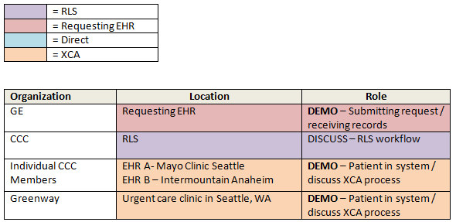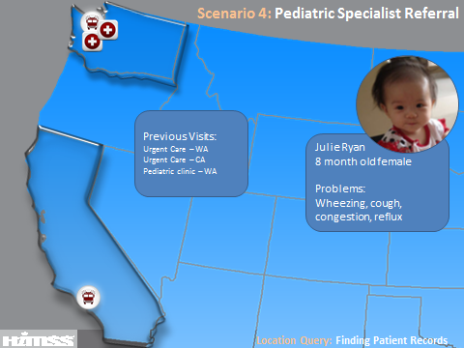
Julie Ryan is an 8 month-old female who lives in Seattle, Washington with her parents and brother. She has a history of respiratory issues and has suffered from wheezing, coughing, retracting and frequent spitting up. Julie has also been seen in urgent care for an ear infection while on a family vacation to Disneyland and for conjunctivitis at another clinic in Seattle. Julie’s PCP, Dr. Vargas, has treated her for these symptoms along with seeing her for her well-baby visits. Julie’s mother, Sarah, does not see improvement and asks Dr. Vargas for a referral to see a pulmonary specialist. Julie is able to choose any pulmonary specialist in network. The pulmonary specialist (GE), Dr. Burchett, utilizes Information Health Exchange (IHE) technology to gather information from Julie’s other medical records to get a holistic view of her medical history and care plans. Records are found at her pediatrician’s office in Seattle (Mayo Clinic -CCC), an urgent care clinic in Anaheim (Intermountain-CCC) and an urgent care clinic in Seattle (Greenway).
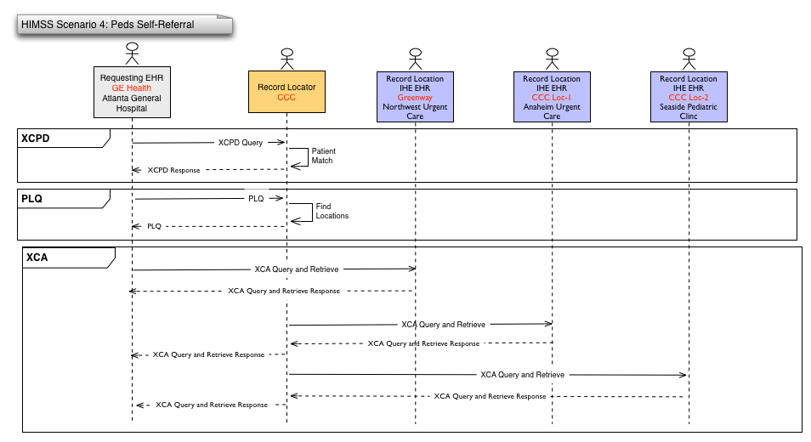

Script for Scenario 4 – Pediatric Specialist
Players
RLS- CCC
Requesting EHR- GE
Location EHRs- CCC, Greenway
Demo Workflow
- Patient presents
  - GE rep tells patient story and overview of scenario
    - 8 month old patient presenting to pulmonary specialist after getting a referral from her PCP
    - The patient has not given adequate advance warning to the specialist and has not provided her medical records from her previous visits to multiple healthcare facilities.
- GE requests locations from CCC (demo)
  - To get the complete list, I’ll use the Surescripts Record Locator and Exchange
- CCC RLS matches patient and provides locations (background)
- GE chooses which locations to request records and sends request for records(demo)
  - Choose all locations
    - We can see that Julie has been to a number of healthcare organizations.
    - Now that I have the list of locations where the patient has been, I’ll send a query to retrieve the patient’s record from those organizations.
- XCA transactions take place between GE and IHE vendors (background)
  - CCC demos their patient in their system and discusses XCA process (demo)
    - Show patient chart in demo system
    - Point out certain pieces of information that will be provided to GE
  - Greenway demos their patient in their system and discusses XCA process
    - Displaying briefly the patient’s chart where the information on the C32 is gathered.
    - Discussing the process of the XCA query from GE to Greenway. We can define XCA if you’d like but since CCC is ahead of this discussing the same thing they will more than likely already have done that.
    - Discussing the benefits of the XCA query for ambulatory providers:
      - Having all patient information on hand from other practices provides better, more efficient care for the patient.
      - Having access to patient allergies and medications can improve patient safety.
      - XCA improves patient care across the community, not just one practice, by providing cohesive care across multiple specialties and different care settings.
- GE receives all 3 documents
  - NorthWest Urgent Care- Greenway
  - Anaheim Urgent Care- CCC
  - Seaside Pediatric Clinic- CCC
- GE shows receipt of all documents and each vendor explains process/benefits
    - Develop a brief “script” here for describing the data we’ve received, highlight the different types of players
  - CCC RLS
Conclusion (GE):
We can see that there’s huge potential in using a record locator service, especially for patients who present to a healthcare organization with no advance warning or information about their previous care. This service puts less of a burden on the patient to detail past encounters and gives the clinicians a more complete record to inform their care.

